***Time and Space complexities :***

1. ***Array :-***

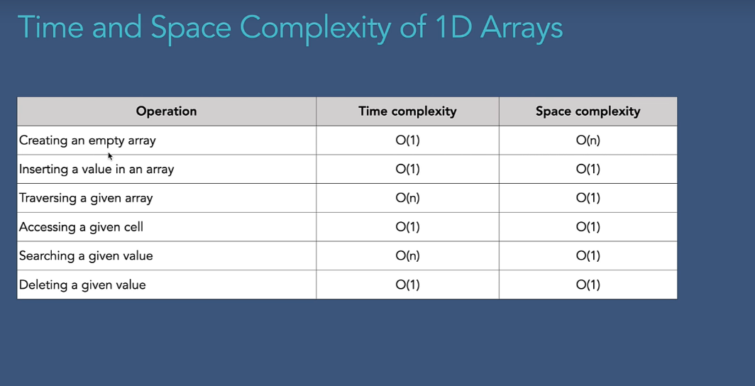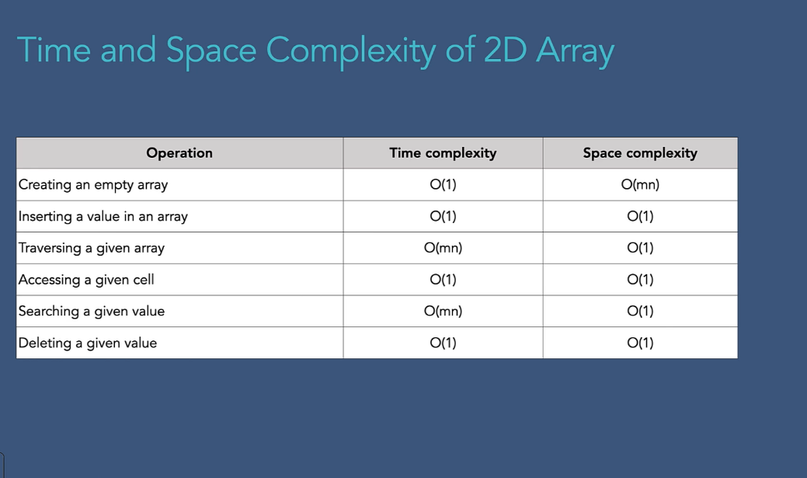

1. ***Linked list***
2. ***Singly linked list***

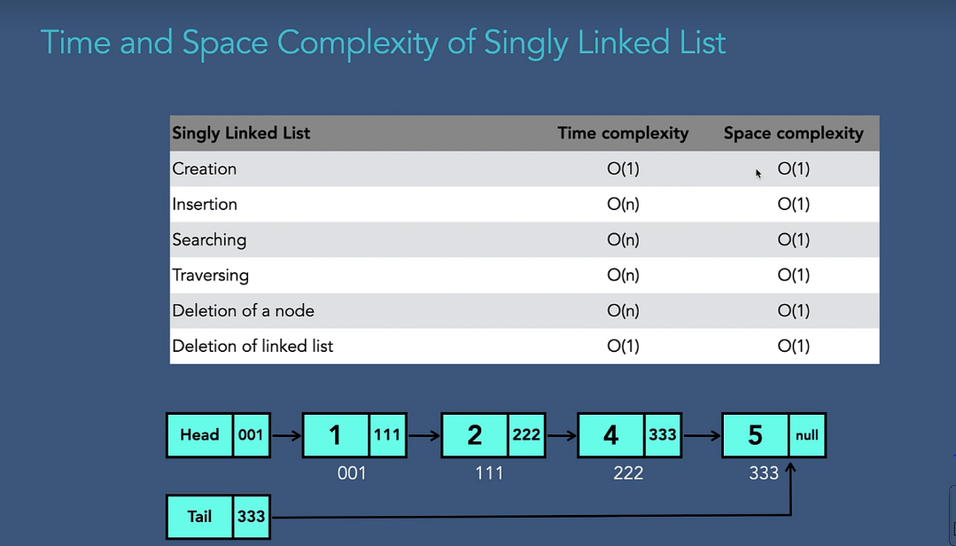

1. ***Circular singly linked list***

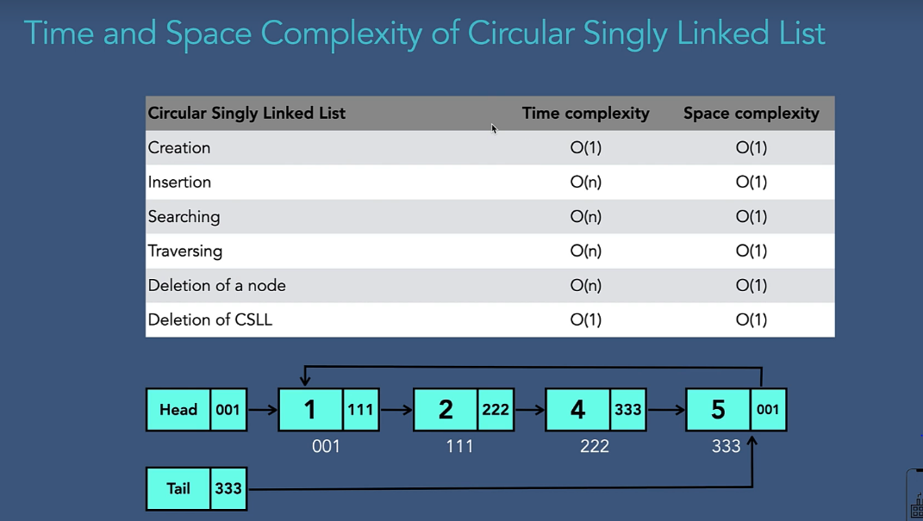

1. ***Doubly linked list :***

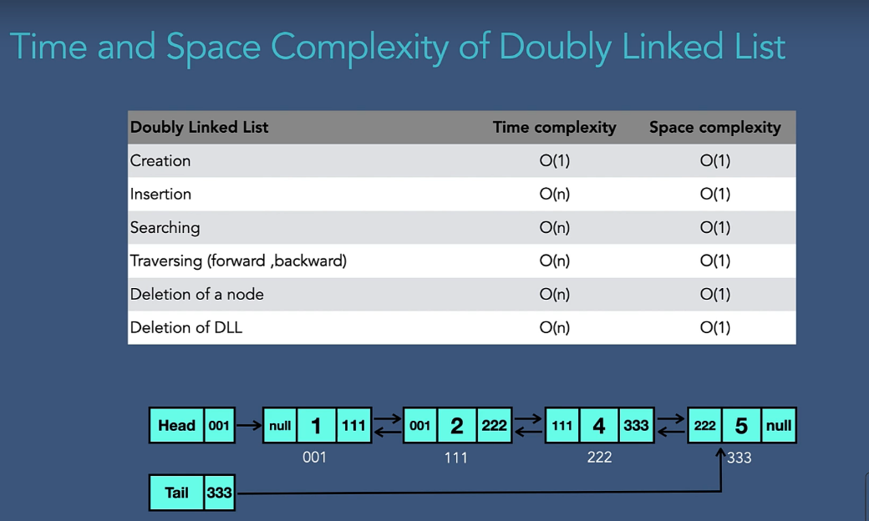

1. ***Circular doubly linked list :***

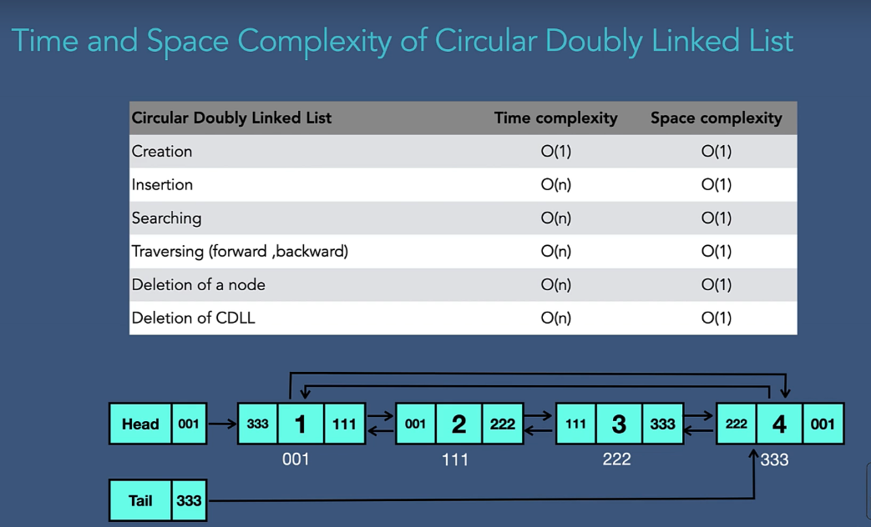

1. ***Array vls Linked list***

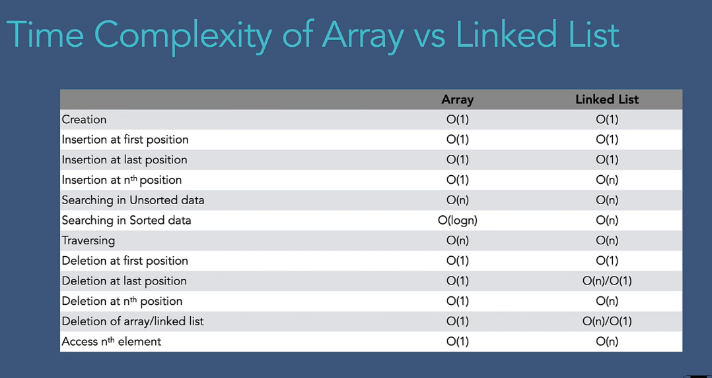

1. ***Stack :***

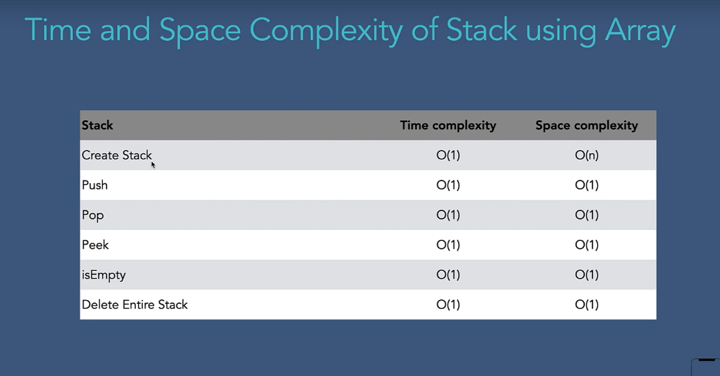

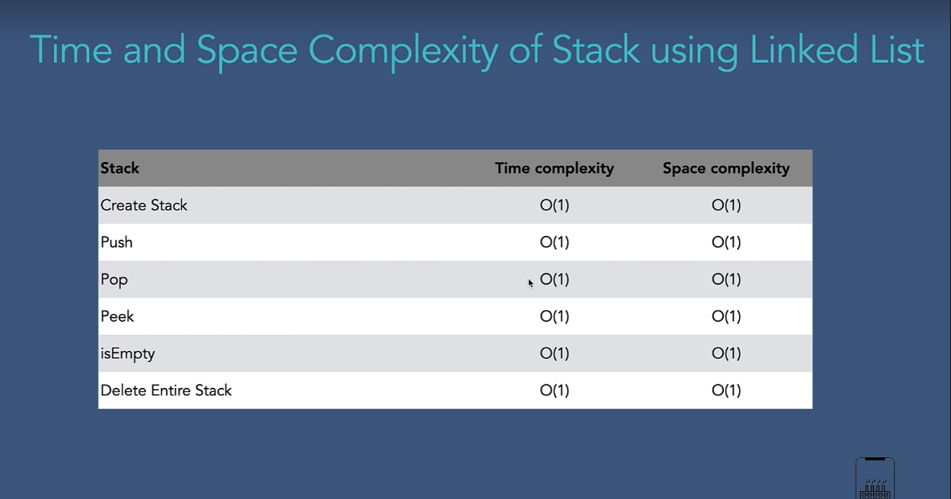

1. ***Queue :***

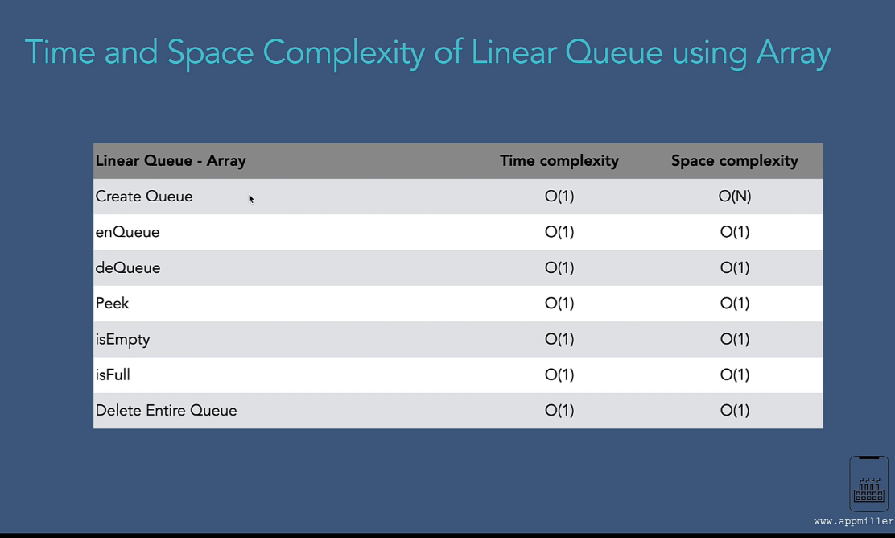

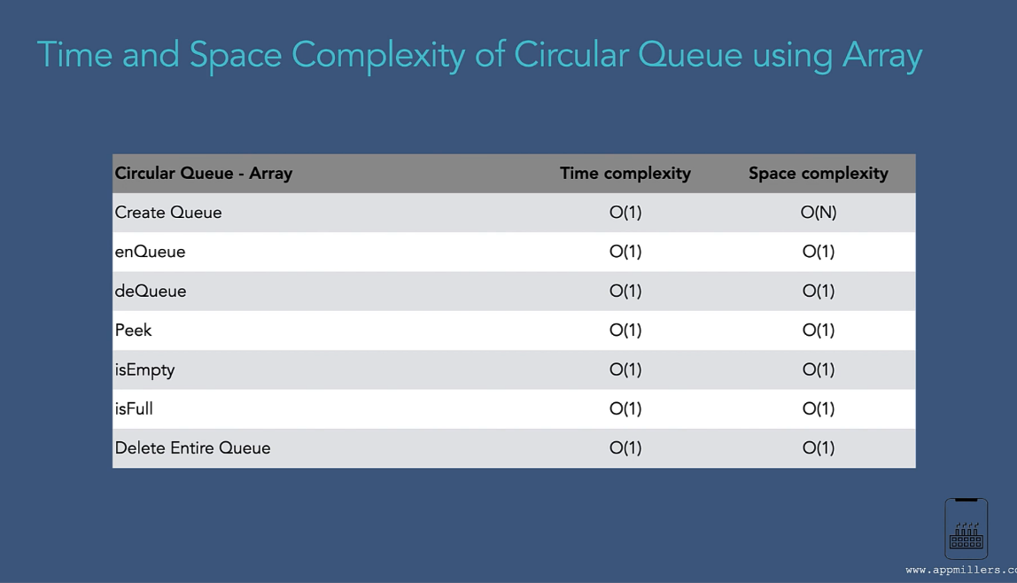

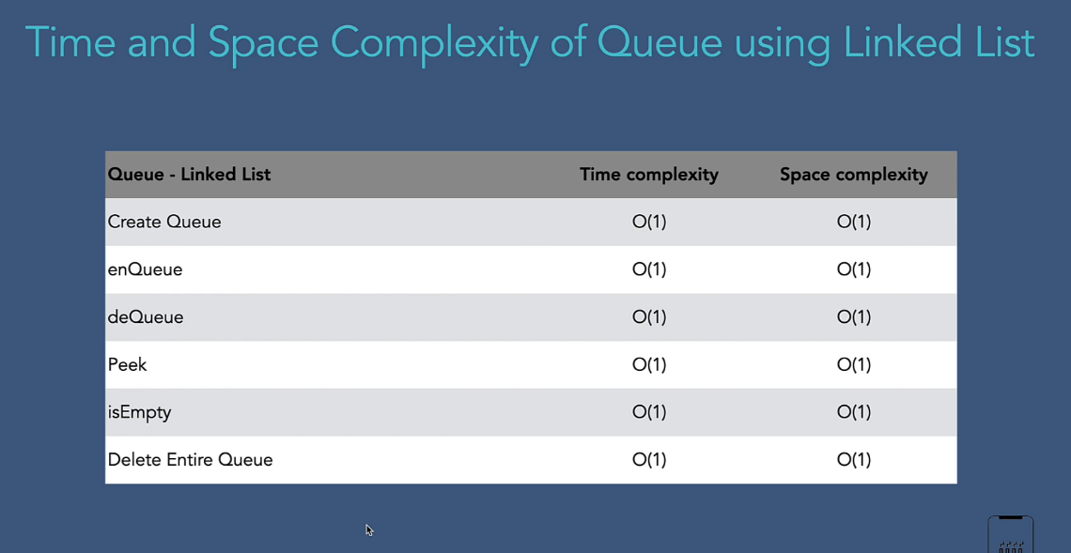

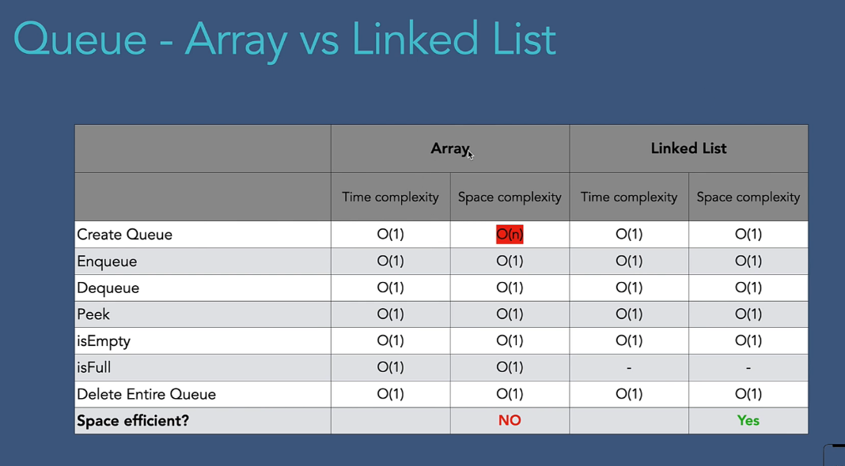

1. ***Tree***
2. ***Binary tree***

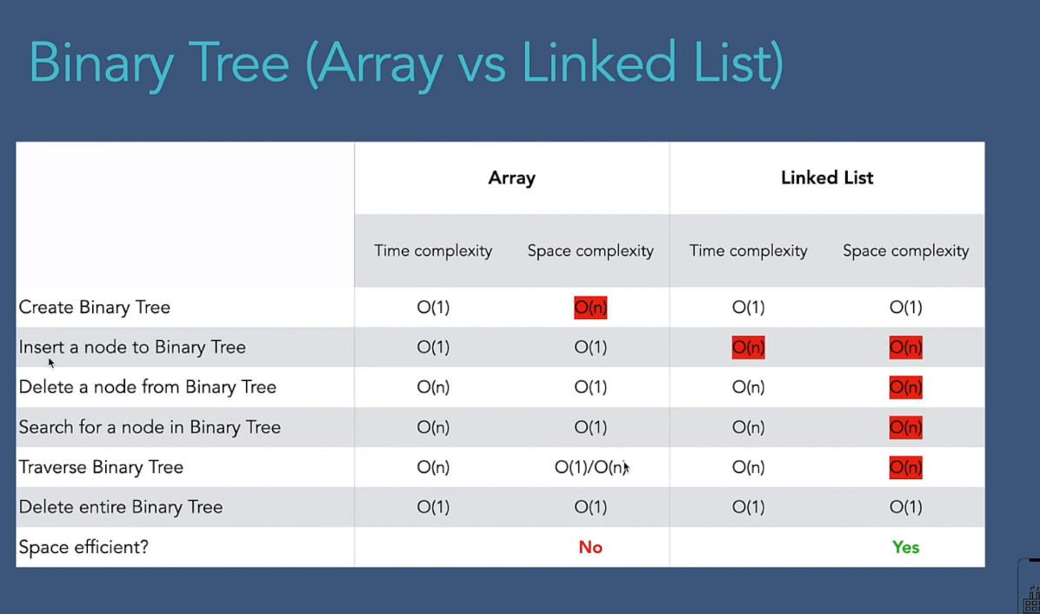

1. ***Binary search tree :***

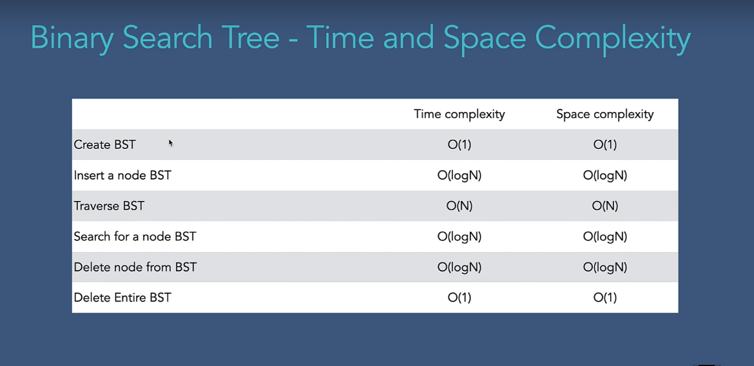

1. ***AVL Tree(Adelson-Velskii and Landis):***

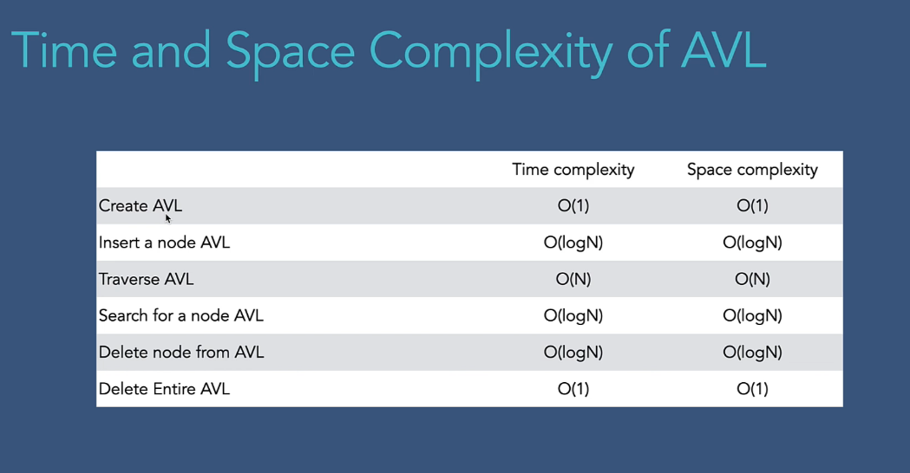

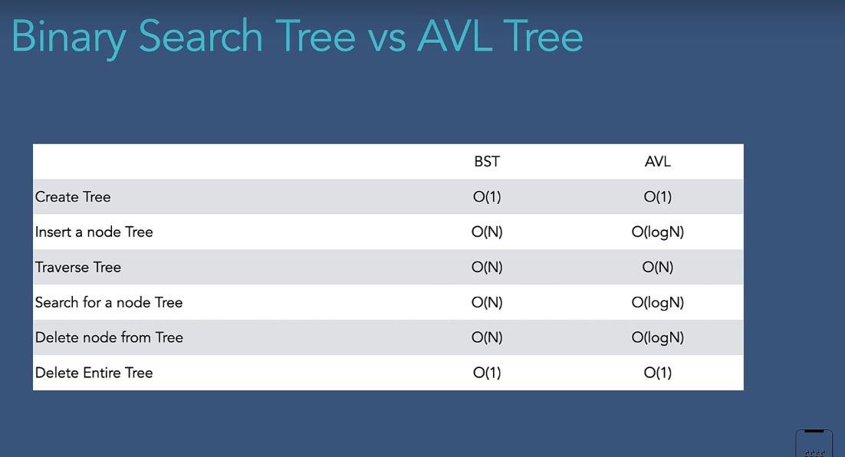



***Binary heap***

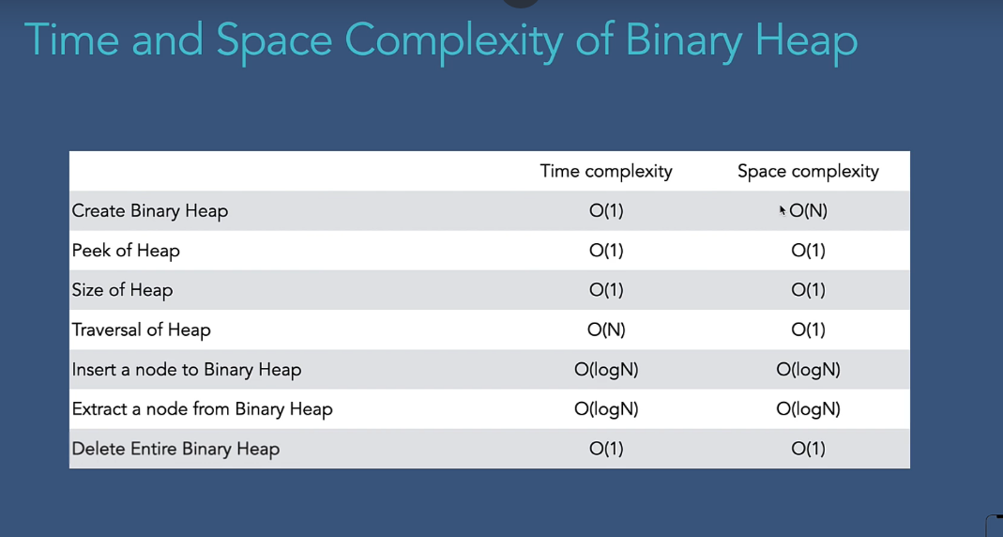

1. ***Sorting :***

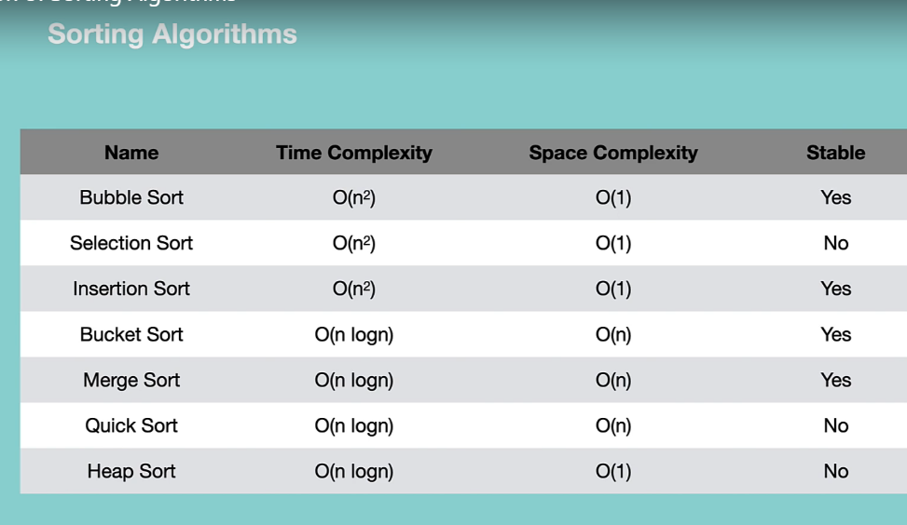

1. ***Graphs***

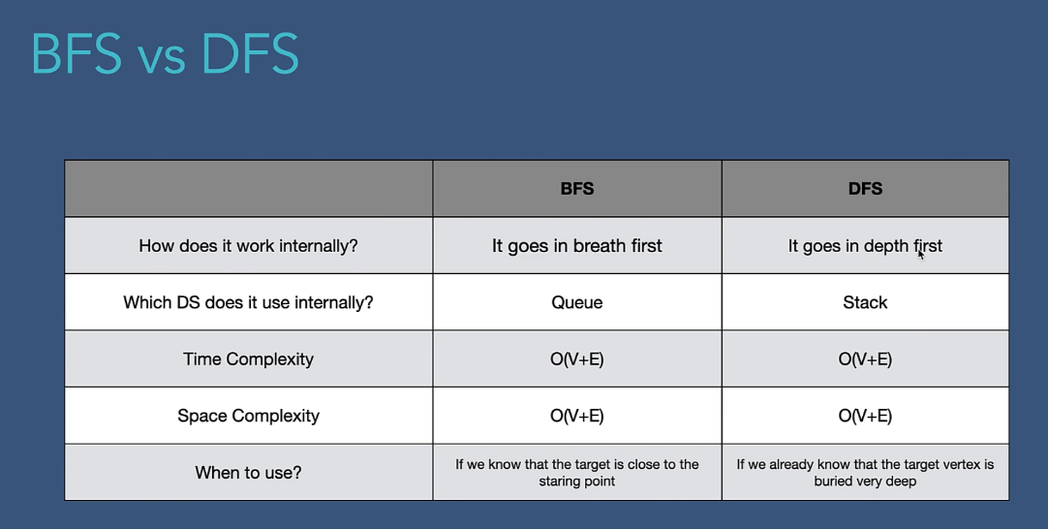

* 1. ***Topological Sort***

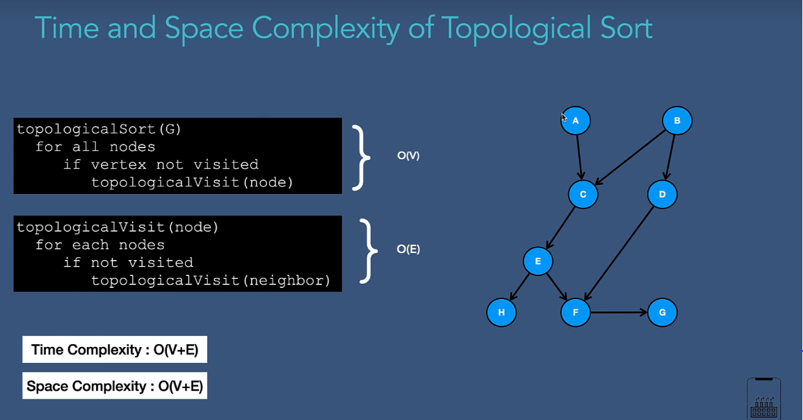

* 1. ***Single Source Shortest path problem(SSSPP)***

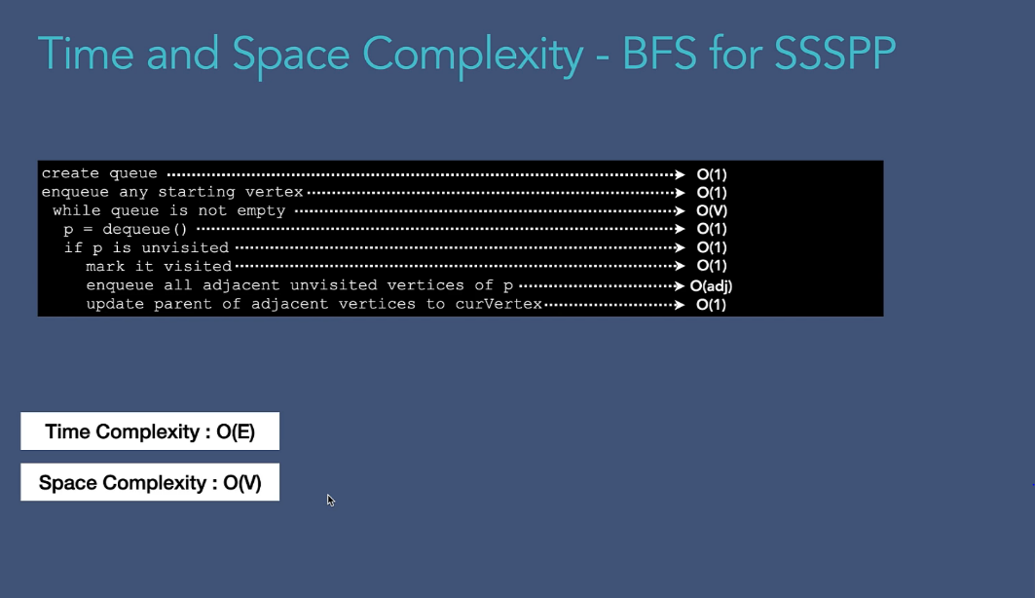

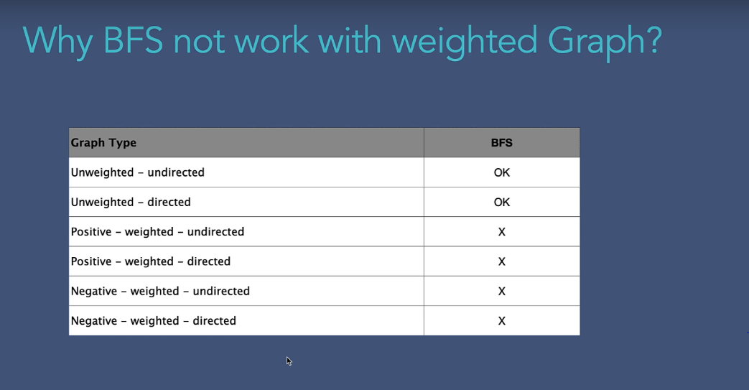

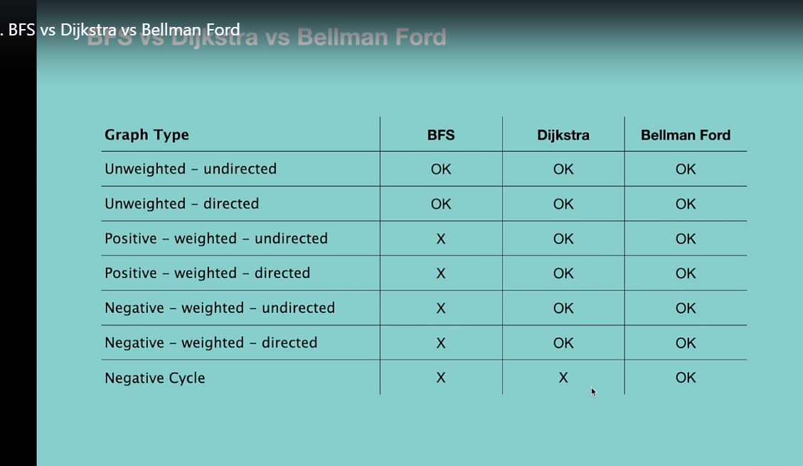

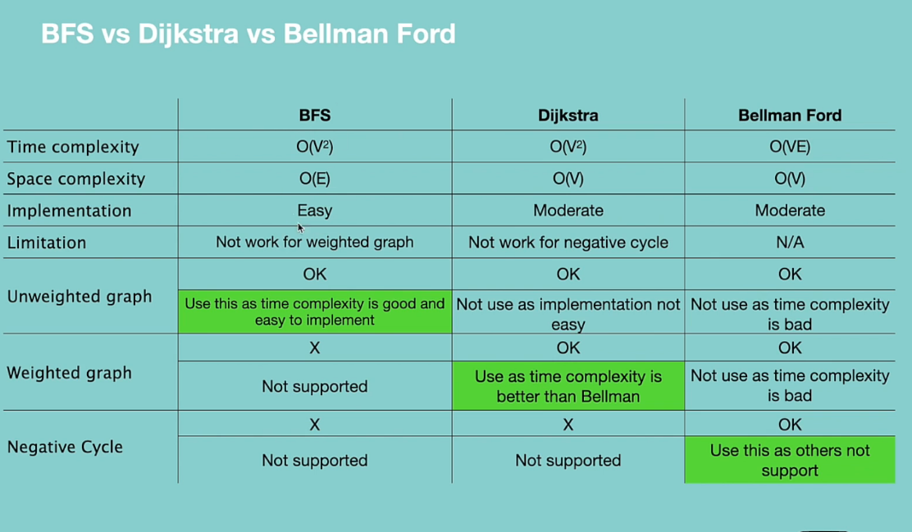

***With single source shortest path problem we can only use BFS without weighted graph but cant use BFS with weighted graphs or DFS weighted or unweighted graphs***

***To solve this problem will use Dijkstra’s algorithm***

***With Dijkstras algorithm we cant use the negative wighted function as with cyclic graph its go to infinite loop to solve this problem we can use Bellman ford algorithm***

***All above algorithm we user for single source when there are multiple source that time we use All pair shortest path problem***

***Floyd warshall algorithm is the second alogorithm to find the shortest path from all the vertices***

***Time complexity for dijkastras algorithm is***

***ElogV and for all pairs and shortest path I t will become v*v2logv – v3logv***

***And for bellmon fords algorithm time complexty is VE which will we V.VE – v^2 *V^2 =v^4***

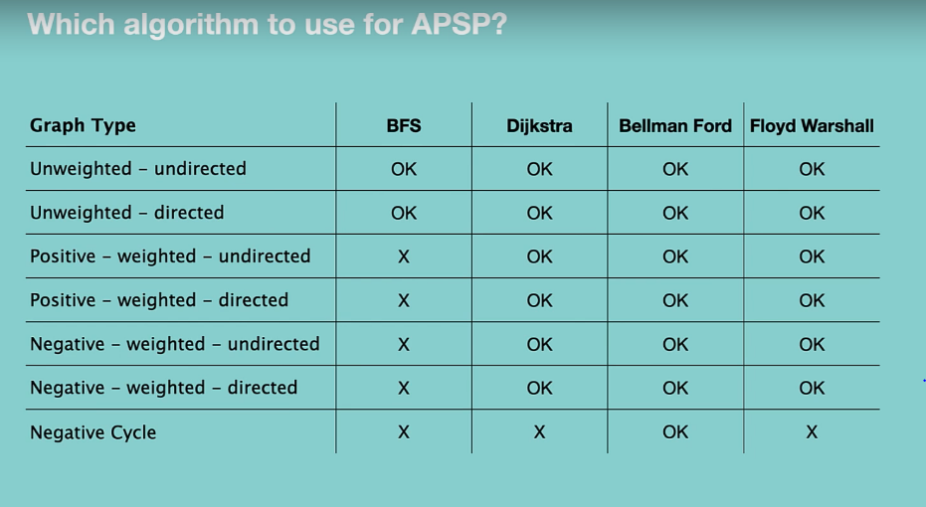

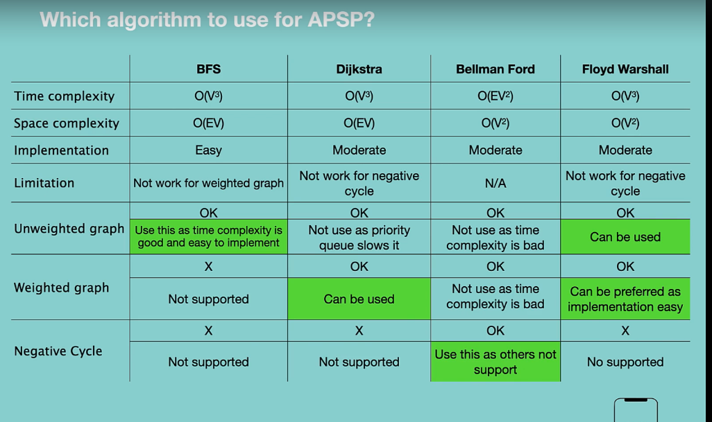

***7.8. Mininmum spanning tree***

***7.8.1 : kruskals algo***

***7.8.2: prims algo***

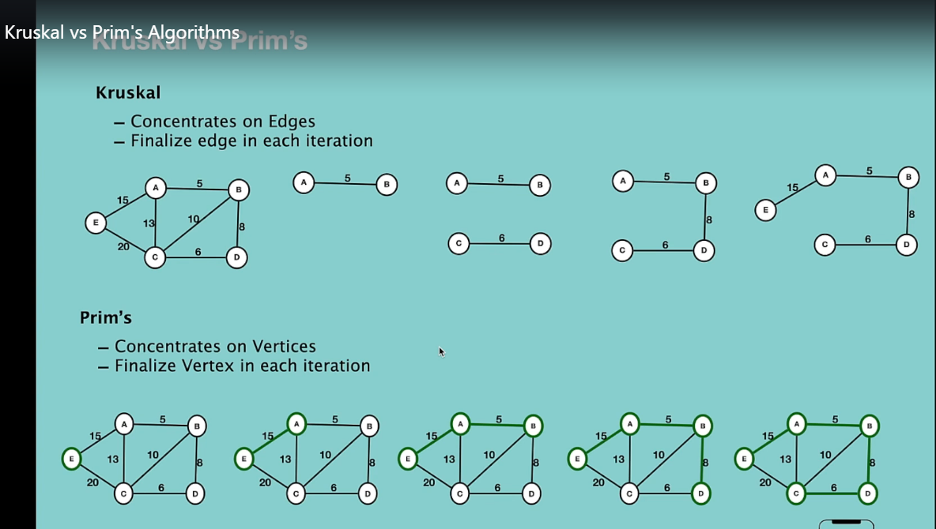

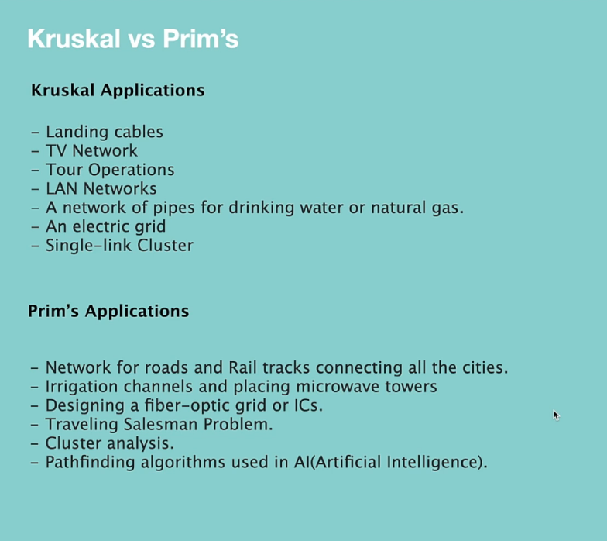

***Dynamic programming***

